Worksheet W.A.37.1

Answer Sheet

Recursive Tree Traversals

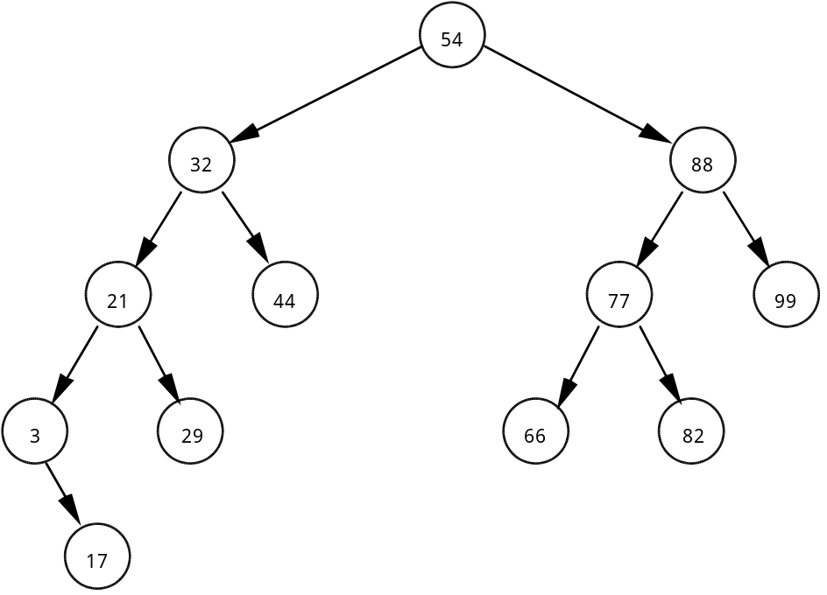

Given the above binary tree, write out the order of the following tree traversal schemes:

1. inorder: 3 17 21 29 32 44 54 66 77 82 88 99

2. preorder: 54 32 21 3 17 29 44 88 77 66 82 99

3. postorder: 17 3 29 21 44 32 66 82 77 99 88 54

4. Suppose this binary tree was saved to disk “inorder.” What would happen when the data file was read from disk and the binary tree was rebuilt? How can this problem be solved?

The tree would be saved to disk in ascending order. When this data file is used to rebuild the tree, the resulting tree is the worst case scenario - a linked list. Instead, the tree should be saved to disk preorder, resulting in the original tree being rebuilt the next time.

5. State the order of searching an ordered binary tree. Explain your answer.

The maximum number of comparisons required would equal the number of levels in the tree plus one. Given the ideal situation of a balanced binary tree, the number of levels would be equal to log2N, where N is the number of data being stored. Therefore, the order of searching an ordered binary tree falls in the category of O(log2N).

